NAAN MUDHALVAN DIGITAL MARKETING PROJECT

# INTRODUCTION

* 1. **OVERVIEW**

In today's fast-paced digital world, where social media is a dominant force, YouTube has become a crucial platform for businesses and individuals alike to showcase their products, services, and ideas. Among the various content formats, the Instagram ad poster is a dynamic tool that can help you achieve your marketing goals. Whether you're looking to promote a product, announce an event, or increase brand awareness, a well-crafted YouTube ad poster can make all the difference.

Brand Name: LEO’S BRISTO

Business: THE COFFEE CARTEL

# PURPOSE

Advertising on YouTube serves several essential purposes for businesses and individuals alike. Here are some of the primary purposes for advertising on YouTube:

* + - Brand Awareness
    - Audience engagement
    - Traffic and website visits
    - Product promotion
    - Influencer Collaboration
    - Sales and Conversions

# PRODUCT DEFINITION AND DESIGN THINKING

* 1. **EMPATHY MAP**

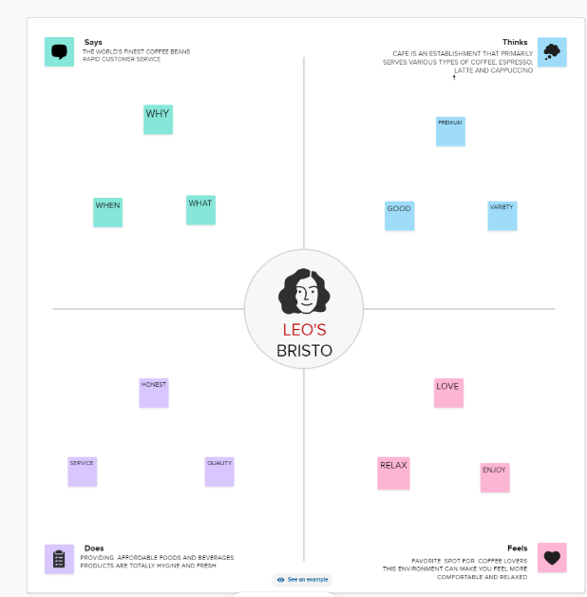

# IDEATION & BRAINSTORMING MAP

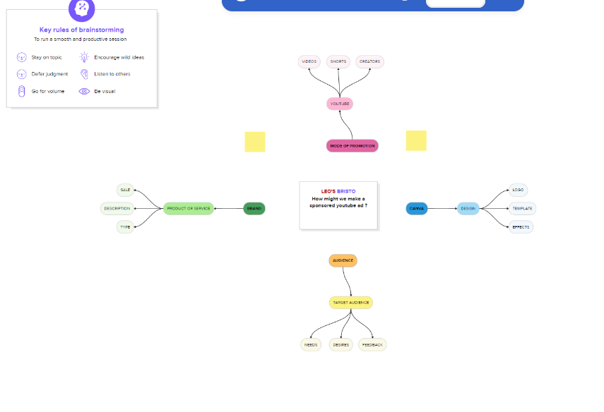

1. **RESULT**

Hence, the YouTube ad Campaign to promote brand recognition, encourage customer engagement and boost sales has been

constructed.

# ADVANTAGES & DISADVANTAGES

Some of the advantages are:

1. Massive, Engaged Audience: Over a billion active users provide a vast reach.
2. Visual Impact: Ideal platform for showcasing products and services through high-quality visuals.
3. Targeted Advertising: Precise audience targeting for effective campaigns.
4. Influencer Collaboration: Partnering with influencers for wider exposure.
5. Insightful Analytics: Detailed data to refine marketing strategies and make data-driven decisions.

These are also some disadvantages associated with digital marketing on instagram such as:

1. Algorithm Changes: Content visibility can be impacted by frequent algorithm updates.
2. High Competition: The platform's popularity means a crowded space, making it harder to stand out.
3. Visual Content Dependency: Non-visual businesses may struggle to create engaging content.

# APPLICATIONS

The following are some of the applications of digital marketing using instagram Product Promotion: Businesses can use Instagram to showcase their products or

services through high-quality images and videos. This platform is especially effective for visually-driven industries like fashion, beauty, and food.

E-commerce: Instagram offers shopping features that enable businesses to sell products directly through the platform. This can streamline the buying process and boost sales for e-commerce companies.

Analytics and Data Insights: The platform provides insights into your audience's behaviour, helping you refine your digital marketing strategy based on data-driven decisions.

# CONCLUSION

In this project, we focused on creating a visually captivating poster for marketing our brand, ‘Das & Co’ on Instagram. Through striking design and compelling visuals, we aimed to enhance brand recognition and engagement. This project exemplifies the power of a well-crafted poster in making a strong visual impact on Instagram,

showcasing the brand's identity and products effectively.

# FUTURE SCOPE

Our project can be improved upon these following aspects in the future,

* 1. A/B Testing for Optimization: Implementing A/B testing strategies for design fine-tuning.
  2. Multichannel Expansion: Adapting the poster for diverse marketing platforms.
  3. Dynamic Personalization: Creating tailored versions for distinct audience segments.
  4. Incorporating Video Elements: Integrating dynamic video content for enhanced engagement.